Trading 2016_9_19

Monday, September 19, 2016

Tuesday, September 20, 2016

The recent low is at 2995.4. There seems to be some sort of support at 3k level either by market consensus or government. In terms of fundamentals, 3000 is a level without much bubble, but one can never be sure.

A share hasn't recovered the huge gap down on Sep 12. Therefore I choose to continue holding.

The rally yesterday morning (19th) and day min at 930 and daymax at 1500 is a sign that people like this level.

Hold this position for a while.

These few sessions taught you a lesson that it is not wise to accumulate too much position over the weekend.

@940 A very solid negative first 10 with a high percentile close. Looks like today will be a bearish session. Nothing to do here.

@957 Market starts off bearish, breaking new lows here, shows the weakness of the market.

USDCNH position is making money.

@1046 Market touched yesterday's lows, filling the gaps of yesterday.

@1301 Probability speaking, given yesterday's high closing percentile, it is negative for today's session.

Wednesday, September 21, 2016

Market was bullish in Europe last night but US did not do particularly well. Fut started with 30 bps premium but slowly that eroded away with very small selling from the retail (as can be seen from the size.

Yesterday fut was quite typical of a Tuesday rally, was weak in the morning and achieved the lows near 2pm then rallied overnight. Tuesday AM session is hurtful as per analysis. A lot of buying went into the market yesterday near the close, therefore the weakness around the open is expected.

@926 prem goes to 23bps as cash indicates 5 bps up.

@930 Cleansing continues which drives investors out of the market. There is almost no volume.

Fut tried to break the 9660 level twice but can't, probably setting up another round of racing to the downside. Volatility remains subdued.

@935 what can be observed is that drops very quickly erase the gains

@with the relative safe level of 3000 around this level, nothing much needs to be done. Market will keep selling off and wash out investors and volumes will keep dropping. Most likely scenario this week is that after fut fails to break highs, more sell-off is expected.

@941 Solid negative first10. Start rolling this position into Oct.

The issue here is that there are no one willing to buy. Chinese are still pouring money into real estate, due to liquidity conditions and ease of mortgage. The question is what will happen after families are stuck with mortgages.

No government really wants to control real estate prices, as this is a source of revenue, this is something that has to be understood. The most effective way to reduce price is increase supply, but government is not doing that. Instead they are adding transaction cost which pushes up the price. They squeeze out supply to emphasize scarcity.

@1019 Fut sells off to flat pd. In markets like this, it is not good to carry a position you need to constantly trade to make money, but you came into this with too much position. Now you have to hold until the position breaks even.

Chinese stock market doesn't have new inflow of money because the currency is depreciating and holding RMB assets won't be attractive. Stock market is not in a bullish trend and people are increasing leverage to buy houses.

@1040 if you feel the market, it doesn't want to rally. People gradually sell off and the volatility will drop to 0.

@1115 As a reflection, should sell position at open at preferred pd levels, trading p/d (non Fri-Mon) seems like a viable way. Today when market opened, market was still at 30 bps premium, should sell some back at this pd. Both on Monday and Tuesday fut was at day highs but it failed to rally the next day, showing weakness. During these scenarios, the best strategy is to trade in the overnight session (again non-Fridays)

@1120 Market at 10bps discount now. Day range so far is 30 bps. Seems valuation has stabilized around these levels.

**Thursday, September 22, 2016**

Yellen was dovish and attempted to put off the hike, US rallied overnight.

XIN gapped up about 50bps, currently at a 40 bps premium.

People didn't want any positioning yesterday in anticipation of last night's risk events. Now with the event over, there could be some moves.

BOJ's moves were considered to be disappointing, and USDJPY was sold to 100 level, picked up 25k here. Long at this level I consider to be quite comfortable.

Futs are quite persistent at the 50 bps prem level.

@936 Mkt quickly sells off when China fails to show signs of confidence. Onshore investors simply took this chance to sell whatever they have, whereas HK is relatively persistent at this level.

AH spread @ Oct 2014 levels as H keeps rallying with A not moving.

The most attractive feature of HK stocks is the correlation with US as well as its exchange rate advantage. H share keeps being bought.

@1349

Fut trading flat/slight discount. pmFirst10 down, amFirst10 down. Market sentiment is still cautious. Price action in the pm is mostly weak on very low volumes.

@1354 Fut dips about 50 bps from the highs, probably the last one of the day.

Aggressive cutting @ 9670 level. Traders are giving up on the pm. The wash was quite aggressive.

Most of uncertain traders are out at this time of the day. Looking at probably some space for a percentile recovery here.

If not, then tomorrow Fri-Mon continuation might be interesting. At this point it depends on if people chase into the Friday possibility. By no means a clean greed rally – this is probably the very initial stages of recovery where people are still selling whenever they can.

@1428

Futures gapped down for Europe at 2pm. After initial weakness, market is crawling back a bit here.

@1433 Rolling the fut costs about 27.5 per lot. Looking for chances to roll now.

@Very weak afternoon with no breakout.

**Friday, September 23, 2016**

Market sold off at the open.

Amfirst10 negative.

Ammax so far is after ten. Today is ok, don't add anymore position.

Volatility is dropping again.

@1054

2823 getting aggressively sold off on little volume. Vols take a plunge in hscei.

@1132

Fut traded within a 30 point range in the AM session. Markets lack direction and momentum. It didn't want to rally yesterday but it had to because cash was rallying.

If pmFirst10 > -0.4%, then trading strategy is suggesting to long.

HSAHP flat this morning.

@1312 +1 9662.5 Reason: Day low and percentile recovery + low percentileY

@1337 Market stalls here, position is flat. Going forward make sure to diversify as much as possible the position, blend in forex and commodities.

@1339 Some rationale for the buy also includes

@1509

As today it is Friday, rebound is weaker than usual earlier in the week.

It usually requires more bullish energy than usual to push up Friday since there are a lot of unknown factors during the weekend.

This week, the important progress is the understanding of the dynamics of interaction between world markets.

On a usual day, US closes at 4am HKT, and Asia follows, and Europe joins at 3pm. On Friday, China is the first to close off for the week, followed by Europe and US. Thus China has a lot of responsibility including starting next week with no information how weekend information is digested by world markets. Therefore, investors tend to be cautious on Fridays in China.

I was asked before the question what are the rationale between strength and weekdays.

Monday – markets are digesting the information over the weekend and emotions are amplified.

Tuesday – due to Monday's overreaction, market usually corrects

Wed – usually an up day in the long run

Thursday – traders take profit from Wednesdays

Friday – last day of the week, buying power has mostly been exhausted.

@1528 Market sold off to 30 bps discount. People are still scared from the Sep 9 drop, therefore they sell off to prevent that. A big portion of it is overreaction, but if Monday opens low it is usually not a good day.

@1532 Panics are severe on Friday evenings. One thing to note is that US has pretty much recovered its losses from Sep 9th drop but China is not even close. Equity market in China is way weaker than the rest of the world at this point. HK as well has recovered most of its losses from Sep 9th.

Start trading some H share futures to gain exposure to the US. Due to HK's currency, the strength vs. A might continue. Do some swing trading with MCH.HK.

Weekly review:

The week gapped up on Monday, got sold off on Tuesday AM, recovered weakly on Tuesday PM. Wednesday got sold again, barely recovered. Yellen came out and was dovish but market was only able to rally until 10:30, this was the max of the week, on Friday close Europe started weak, china just took that opportunity to sell off.

Overall, it is clear the market does not want to rally, it reluctantly rallies on Thursday but you see people are reducing exposure to A share. Domestic investors are losing their interest (as can be seen from the ultra low volatility) and people are reluctant to hold RMB.

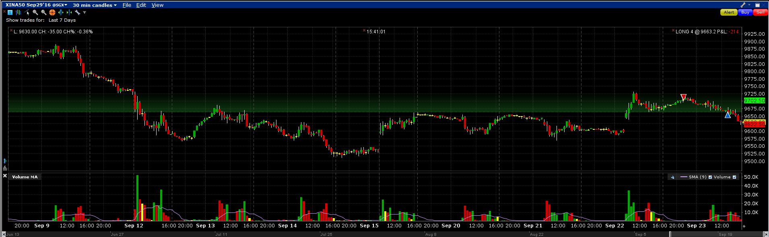

H shares:

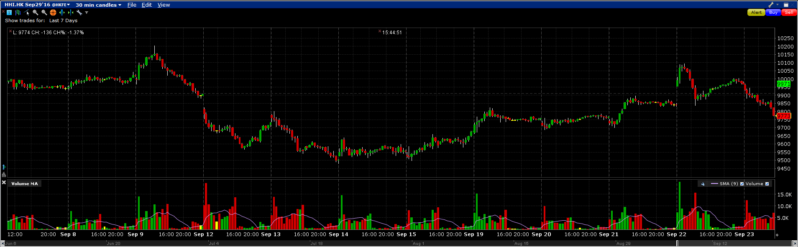

An interesting observation is that H share is usually faster at interpreting information and acting faster. On Sep 22, market sold off much harder on H and on Friday it didn't even have a reasonable rebound.

No buying on dips on Friday allowed. On Sep 9th I got stuck going into the position on Friday, wait until Monday to see what happens.

It's hard to even keep flat recently. Trading needs to be perfect to make money in this market.